Q1:
#include <iostream>
using namespace std;

class resize_matrix {
public:
int rows_, columns_;
int** newarr;

resize_matrix() {
newarr = NULL;
rows_ = 0;
columns_ = 0;
}

void create(int r, int c) {
rows_ = r;
columns_ = c;

newarr = new int*[rows_];
for (int i = 0; i < rows_; i++) {
newarr[i] = new int[columns_];
}
}

void input() {
for (int i = 0; i < rows_; i++) {
for (int j = 0; j < columns_; j++) {
cin >> newarr[i][j];
}
}
}

void resize_array(int newrows, int newcols, int initValue = 0) {
int** temp = new int*[newrows];
for (int i = 0; i < newrows; i++) {
temp[i] = new int[newcols];
}

for (int i = 0; i < newrows; i++) {
for (int j = 0; j < newcols; j++) {
if (i < rows_ && j < columns_)
temp[i][j] = newarr[i][j];
else
temp[i][j] = initValue;
}
}

for (int i = 0; i < rows_; i++) {
delete[] newarr[i];
}
delete[] newarr;

newarr = temp;
rows_ = newrows;
columns_ = newcols;
}

int** matrix_transpose() {
int** trans = new int*[columns_];
for (int i = 0; i < columns_; i++) {
trans[i] = new int[rows_];
}

for (int i = 0; i < rows_; i++) {
for (int j = 0; j < columns_; j++) {
trans[j][i] = newarr[i][j];
}
}
return trans;
}

void add_two_odd_index() {
for (int i = 0; i < rows_; i++) {
for (int j = 0; j < columns_; j++) {
if ((i + j) % 2 != 0) {
newarr[i][j] += 2;
}
}
}
}

void display() {
for (int i = 0; i < rows_; i++) {
for (int j = 0; j < columns_; j++) {
cout << newarr[i][j] << " ";
}
cout << endl;
}
}

~resize_matrix() {
if (newarr != NULL) {
for (int i = 0; i < rows_; i++) {
delete[] newarr[i];
}
delete[] newarr;
}
}
};

int main() {
int rows, cols;
cout << "Enter rows and columns: ";
cin >> rows >> cols;

resize_matrix obj;
obj.create(rows, cols);

cout << "Enter matrix elements:" << endl;
obj.input();

cout << endl << "Original Matrix:" << endl;
obj.display();

int newrows, newcols;
cout << endl << "Enter new rows and columns: ";
cin >> newrows >> newcols;

obj.resize_array(newrows, newcols, 0);

cout << endl << "Resized Matrix:" << endl;
obj.display();

obj.add_two_odd_index();
cout << endl << "After adding 2 to odd indices:" << endl;
obj.display();

int** trans = obj.matrix_transpose();
cout << endl << "Transpose Matrix:" << endl;
for (int i = 0; i < obj.columns_; i++) {
for (int j = 0; j < obj.rows_; j++) {
cout << trans[i][j] << " ";
}
cout << endl;
}

for (int i = 0; i < obj.columns_; i++) {
delete[] trans[i];
}
delete[] trans;

return 0;
}

Ouput:
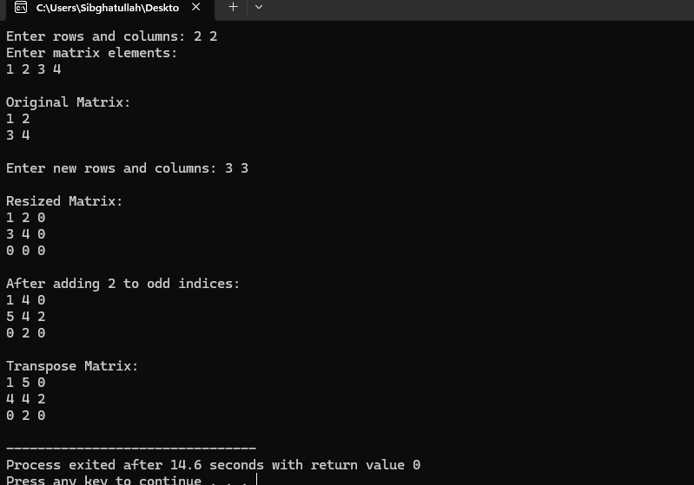
Q2:
#include<iostream>
using namespace std;

int main(){
int students = 5;
int subjects = 4;
int t_marks = 0;

int* student_total_marks = new int[students];
int* student_avg_marks = new int[subjects];

int** arr = new int*[students];
for(int i = 0 ; i < students ; i++){
arr[i] = new int[subjects];
}

for(int i = 0 ; i < students; i++){
student_total_marks[i] = 0;
}

for(int i = 0 ; i < subjects; i++){
student_avg_marks[i] = 0;
}

cout<<"Enter the marks of each subject for each student"<<endl;

for(int i = 0 ; i < students ; i++){
cout<<"Enter the marks for the student# "<<i+1<<endl;
for(int j = 0 ; j < subjects ; j++){
cout<<"Subject#"<<j+1<<". ";
cin>>arr[i][j];
}
cout<<endl;
}

for(int i = 0 ; i < students ; i++){
for(int j = 0 ; j < subjects ; j++){
student_total_marks[i] += arr[i][j];
}
}

for(int i = 0 ; i < subjects; i++){
t_marks = 0;
for(int j = 0 ; j < students ; j++){
t_marks += arr[j][i];
}
student_avg_marks[i] = t_marks / students;
}

cout<<"Total marks of each student are:"<<endl;
for(int i = 0 ; i < students; i++){
cout<<"Student "<<i+1<<". "<<student_total_marks[i]<<endl;
}

cout<<endl;

cout<<"Average marks of each subject are:"<<endl;
for(int i = 0 ; i < subjects; i++){
cout<<"Subject "<<i+1<<". "<<student_avg_marks[i]<<endl;
}

cout<<endl;

int top_marks = student_total_marks[0];
int topper = 1;

for(int i = 1 ; i < students; i++){
if(student_total_marks[i] > top_marks){
top_marks = student_total_marks[i];
topper = i + 1;
}
}

cout<<"Topper student is Student "<<topper<<" with total marks "<<top_marks<<endl;

for(int i = 0 ; i < students; i++){
delete[] arr[i];
}
delete[] arr;
delete[] student_total_marks;
delete[] student_avg_marks;

return 0;
}

Output:
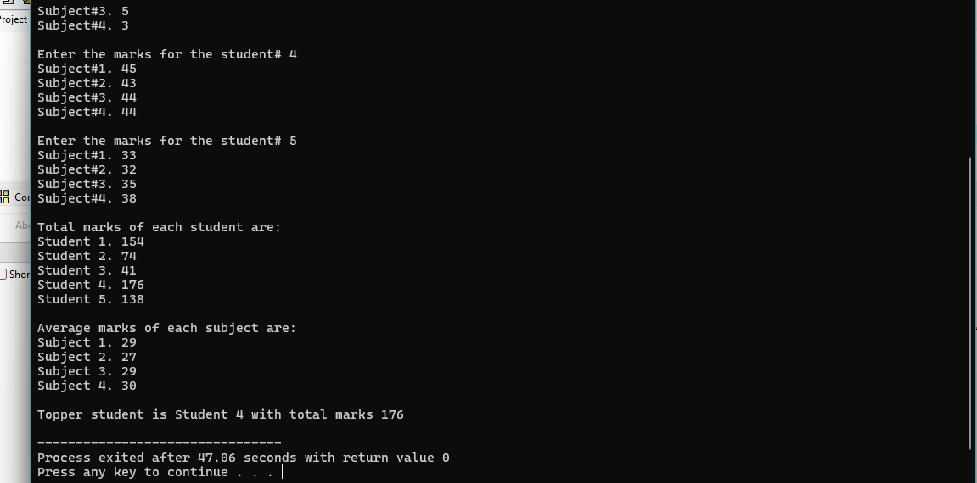

Q3:
#include<iostream>
using namespace std;
int main(){
int subjects = 5;
int depart;
cout<<"Enter the number of departments: ";
cin>>depart;
int* students = new int[depart];
cout<<"Enter the students in each department: ";
for(int i = 0 ;i < depart; i++){
cout<<"Enter the no of students into the depart# "<<i+1<<". ";
cin>>students[i];
}

int** deptmarks = new int*[depart];
for(int i = 0 ; i < depart ; i++){
deptmarks[i] = new int [students[i]];
}

cout<<"Enter the marks of each subject for each student: "<<endl;
for(int i = 0 ; i < depart; i++){
for(int j = 0 ; j < students[i] ; j++){
int total = 0;
int m = 0;
cout<<"Enter the marks for student# "<<j+1<<". "<<endl;

for(int k = 0 ; k < subjects ; k++){
cout<<"Enter the marks for subject#"<<k+1<<". ";
cin>>m;
total += m;
}

deptmarks[i][j] = total;
}
}

for(int i = 0 ; i < depart ; i++){
int highest = deptmarks[i][0];
int lowest = deptmarks[i][0];
int sum = 0;

for(int j = 0 ; j < students[i] ; j++){
if(deptmarks[i][j] > highest)
highest = deptmarks[i][j];
if(deptmarks[i][j] < lowest)
lowest = deptmarks[i][j];
sum += deptmarks[i][j];
}

float avg = (float)sum / students[i];

cout<<"Department# "<<i+1<<endl;
cout<<"Highest Marks: "<<highest<<endl;
cout<<"Lowest Marks: "<<lowest<<endl;
cout<<"Average Marks: "<<avg<<endl;
}

for(int i = 0 ; i < depart ; i++){
delete[] deptmarks[i];
}
delete[] deptmarks;
delete[] students;

}

Output:
